12
DECISION MAKING TOOLS
Module
The techniques in this module will help you to make the best decisions possible with the information you have available. With these tools you will be able to map out the likely consequences of decisions, work out the importance of individual factors, and choose the best course of action to take.

Tools to be discussed are:
- Pareto Analysis. Selecting the most important changes to make.
- Paired Comparison Analysis. Evaluating the relative importance of different options.
- Grid Analysis. Selecting between good options.
- Decision Trees. Choosing between options by projecting likely outcomes.
- PMI. Weighing the pros and cons of a decision.
- Force Field Analysis. Analyzing the pressures for and against change.
- Six Thinking Hats. Looking at a decision from all points of view.
- Cost/Benefit Analysis. Seeing whether a change is worth making.
In this module we will look at a set of good techniques that help you to select between different options. These are very useful when you have to take a go/no-go decision. This part finishes by discussing Decision Trees, which are excellent Decision Making tools. If you are suffering from decidophobia, these tools will get you moving again.
Do remember, though, that the tools in this module exist only to assist your intelligence and common sense. These are your most important assets in good Decision Making.

Pareto Analysis - Choosing the Most Important Changes to Make
Pareto analysis is a very simple technique that helps you to choose the most effective changes to make.
It uses the Pareto principle - the idea that by doing 20% of work you can generate 80% of the advantage of doing the entire job. Pareto analysis is a formal technique for finding the changes that will give the biggest benefits. It is useful where many possible courses of action are competing for your attention.
How to use tool:
To start using the tool, write out a list of the changes you could make. If you have a long list, group it into related changes.
Then score the items or groups. The scoring method you use depends on the sort of problem you are trying to solve. For example, if you are trying to improve profitability, you would score options on the basis of the profit each group might generate. If you are trying to improve customer satisfaction, you might score on the basis of the number of complaints eliminated by each change.
The first change to tackle is the one that has the highest score. This one will give you the biggest benefit if you solve it.
The options with the lowest scores will probably not even be worth bothering with - solving these problems may cost you more than the solutions are worth.
Example:
A manager has taken over a failing service center. He commissions research to find out why customers think that service is poor.
He gets the following comments back from the customers:
- Phones are only answered after many rings.
- Staff seem distracted and under pressure.
- Engineers do not appear to be well organized. They need second visits to bring extra parts. This means that customers have to take more holidays to be there a second time.
- They do not know what time they will arrive. This means that customers may have to be in all day for an engineer to visit.
- Staff members do not always seem to know what they are doing.
- Sometimes when staff members arrive, the customer finds that the problem could have been solved over the phone.
The manager groups these problems together. He then scores each group by the number of complaints, and orders the list:
- Lack of staff training: items 5 and 6: 51 complaints
- Too few staff: items 1, 2 and 4: 21 complaints
- Poor organization and preparation: item 3: 2 complaints
By doing the Pareto analysis above, the manager can better see that the vast majority of problems (69%) can be solved by improving staff skills.
Once this is done, it may be worth looking at increasing the number of staff members. Alternatively, as staff members become more able to solve problems over the phone, maybe the need for new staff members may decline.
It looks as if comments on poor organization and preparation may be rare, and could be caused by problems beyond the manager's control.
By carrying out a Pareto Analysis, the manager is able to focus on training as an issue, rather than spreading effort over training, taking on new staff members, and possibly installing a new computer system.
Key points:
Pareto Analysis is a simple technique that helps you to identify the most important problem to solve.
To use it:
- List the problems you face, or the options you have available
- Group options where they are facets of the same larger problem
- Apply an appropriate score to each group
- Work on the group with the highest score
Pareto analysis not only shows you the most important problem to solve, it also gives you a score showing how severe the problem is.

Paired Comparison Analysis - Working Out the Relative Importance of Different Options

Paired Comparison Analysis helps you to work out the importance of a number of options relative to each other. It is particularly useful where you do not have objective data to base this on.
This makes it easy to choose the most important problem to solve, or select the solution that will give you the greatest advantage. Paired Comparison Analysis helps you to set priorities where there are conflicting demands on your resources.
It is also an ideal tool for comparing "apples with oranges" - completely different options such as whether to invest in marketing, a new IT system or a new piece of machinery. These decisions are usually much harder than comparing three possible new IT systems, for example.
How to use tool:
To use the technique, you will be needing a worksheet. You can use this to compare each option with each other option, one-by-one. For each comparison, you will decide which of the two options is most important, and then assign a score to show how much more important it is.
Follow these steps to use the technique:
- List the options you will compare. Assign a letter to each option.
- Mark the options as row and column headings on the worksheet.
- Within the cells compare the option in the row with the one in the column. For each cell, decide which of the two options is more important. Write down the letter of the more important option in the cell, and score the difference in importance from 0 (no difference) to 3 (major difference).
- Finally, consolidate the results by adding up the total of all the values for each of the options. You may want to convert these values into a percentage of the total score.

Example:
As a simple example, an entrepreneur is looking at ways in which she can expand her business. She has limited resources, but also has the options she lists below:
- Expand into overseas markets
- Expand in home markets
- Improve customer service
- Improve quality
Firstly she draws up the Paired Comparison Analysis table in Figure 1:
Figure 1: Example Paired Comparison Analysis Table (not filled in):
 | Overseas Market (A) | Home  Market (B) | Customer  Service (C) | Quality  (D)
Overseas Market  (A) | Blocked Out  (Step 3)
Home Market  (B) | Blocked Out  (Step 4) | Blocked Out  (Step 3)
Customer Service  (C) | Blocked Out  (Step 4) | Blocked Out  (Step 4) | Blocked Out  (Step 3)
Quality  (D) | Blocked Out  (Step 4) | Blocked Out  (Step 4) | Blocked Out  (Step 4) | Blocked Out  (Step 3)
Then she compares options, writes down the letter of the most important option, and scores their difference in importance. An example of how she might do this is shown in figure 2:
Figure 2: Example Paired Comparison Analysis Table (filled in):
 | Overseas Market (A) | Home  Market (B) | Customer  Service (C) | Quality  (D)
Overseas Market  (A) |  | A,2 | C,1 | A,1
Home Market  (B) |  |  | C,1 | B,1
Customer Service  (C) |  |  |  | C,2
Quality
(D)
Finally she adds up the A, B, C and D values, and converts each into a percentage of the total. This gives these totals:
- A = 3 (37.5%)
- B = 1 (12.5%)
- C = 4 (50%)
- D = 0.
Here it is most important to improve customer service (C) and then to tackle export markets (A). Quality is not a high priority - perhaps it is good already.
Key points:
Paired Comparison Analysis is a good way of weighing up the relative importance of different courses of action. It is useful where priorities are not clear, or are competing in importance.
The tool provides a framework for comparing each course of action against all others, and helps to show the difference in importance between factors.

Grid Analysis - Making a Choice Where Many Factors must be Balanced
Grid Analysis (also known as Decision Matrix analysis, Pugh Matrix analysis or MAUT which stands for Multi-Attribute Utility Theory) is a useful technique to use for making a decision. Decision matrices are most effective where you have a number of good alternatives and many factors to take into account.
How to use tool:
The first step is to list your options and then the factors that are important for making the decision. Then use a worksheet. Lay the options out on the worksheet table, with options as the row labels, and factors as the column headings.
Next, work out the relative importance of the factors in your decision. Show these as numbers. We will use these to weight your preferences by the importance of the factor. These values may be obvious. If they are not, then use a technique such as Paired Comparison Analysis to estimate them.
The next step is to work your way across your table, scoring each option for each of the important factors in your decision. Score each option from 0 (poor) to 3 (very good). Note that you do not have to have a different score for each option - if none of them are good for a particular factor in your decision, then all options should score 0.

Now multiply each of your scores by the values for your relative importance. This will give them the correct overall weight in your decision.
Finally add up these weighted scores for your options. The option that scores the highest wins!

Example:
A windsurfing enthusiast is about to replace his car. He needs one that not only carries a board and sails, but also that will be good for business travel. He has always loved open-topped sports cars. No car he can find is good for all three things.
His options are:
- A four wheel drive (4x4), hard topped vehicle
- A comfortable 'family car'
- An estate car
- A sports car
Criteria that he wants to consider are:
- Cost
- Ability to carry a sail board at normal driving speed
- Ability to store sails and equipment securely
- Comfort over long distances
- Fun!
- Nice look and build quality to car
Firstly he draws up the table shown in Figure 1, and scores each option by how well it satisfies each factor:

Figure 1: Example Grid Analysis Showing Unweighted Assessment of How Each Type of Car Satisfies Each Factor
Factors: | Cost | Board | Storage | Comfort | Fun | Look | Total
Weights:
Sports Car | 1 | 0 | 0 | 1 | 3 | 3
4x4 | 0 | 3 | 2 | 2 | 1 | 1
Family Car | 2 | 2 | 1 | 3 | 0 | 0
Estate Car | 2 | 3 | 3 | 3 | 0 | 1

Next he decides the relative weights for each of the factors. He multiplies these by the scores already entered, and totals them. This is shown in Figure 2:
Figure 2: Example Grid Analysis Showing Weighted Assessment of How Each Type of Car Satisfies Each Factor
Factors: | Cost | Board | Storage | Comfort | Fun | Look | Total
Weights: | 4 | 5 | 1 | 2 | 3 | 4
Sports Car | 4 | 0 | 0 | 2 | 9 | 12 | 27
4x4 | 0 | 15 | 2 | 4 | 3 | 4 | 28
Family Car | 8 | 10 | 1 | 6 | 0 | 0 | 25
Estate Car | 8 | 15 | 3 | 6 | 0 | 4 | 36
This gives an interesting result: Despite its lack of fun, an estate car may be the best choice.
If the wind-surfer still feels unhappy with the decision, maybe he has underestimated the importance of one of the factors. Perhaps he should weight 'fun' by 7!
Key points:
Grid Analysis helps you to decide between several options, while taking many different factors into account.
To use the tool, lay out your options as rows on a table. Set up the columns to show your factors. Allocate weights to show the importance of each of these factors. Score each choice for each factor using numbers from 0 (poor) to 3 (very good). Multiply each score by the weight of the factor, to show its contribution to the overall selection. Finally add up the total scores for each option. Select the highest scoring option.
Grid Analysis is the simplest form of Multiple Criteria Decision Analysis (MCDA), also known as Multiple Criteria Decision Aid or Multiple Criteria Decision Management (MCDM). Sophisticated MCDA is involves highly complex modeling of different potential scenarios and advanced mathematics.

Decision Tree Analysis - Choosing Between Options by Projecting Likely Outcomes

Decision Trees are excellent tools for helping you to choose between several courses of action. They provide a highly effective structure within which you can lay out options and investigate the possible outcomes of choosing those options. They also help you to form a balanced picture of the risks and rewards associated with each possible course of action.
How to use tool:
You start a Decision Tree with a decision that you need to make. Draw a small square to represent this towards the left of a large piece of paper.
From this box draw out lines towards the right for each possible solution, and write that solution along the line. Keep the lines apart as far as possible so that you can expand your thoughts.
At the end of each line, consider the results. If the result of taking that decision is uncertain, draw a small circle. If the result is another decision that you need to make, draw another square. Squares represent decisions, and circles represent uncertain outcomes. Write the decision or factor above the square or circle. If you have completed the solution at the end of the line, just leave it blank.
Starting from the new decision squares on your diagram, draw out lines representing the options that you could select. From the circles draw lines representing possible outcomes. Again make a brief note on the line saying what it means. Keep on doing this until you have drawn out as many of the possible outcomes and decisions as you can see leading on from the original decisions.
An example of the sort of thing you will end up with is shown in Fig. 1:
Once you have done this, review your tree diagram. Challenge each square and circle to see if there are any solutions or outcomes you have not considered. If there are, draw them in. If necessary, redraft your tree if parts of it are too congested or untidy. You should now have a good understanding of the range of possible outcomes of your decisions.

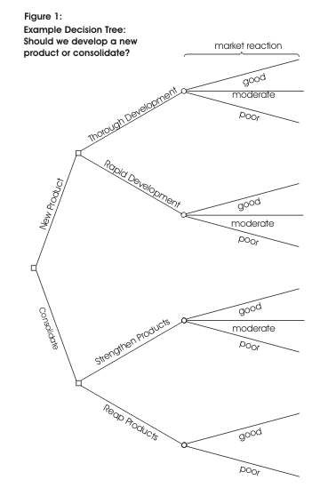
Evaluating Your Decision Tree
Now you are ready to evaluate the decision tree. This is where you can work out which option has the greatest worth to you. Start by assigning a cash value or score to each possible outcome. Estimate how much you think it would be worth to you if that outcome came about.
Next look at each circle (representing an uncertainty point) and estimate the probability of each outcome. If you use percentages, the total must come to 100% at each circle. If you use fractions, these must add up to 1. If you have data on past events you may be able to make rigorous estimates of the probabilities. Otherwise write down your best guess.
This will give you a tree like the one shown in Figure 2:
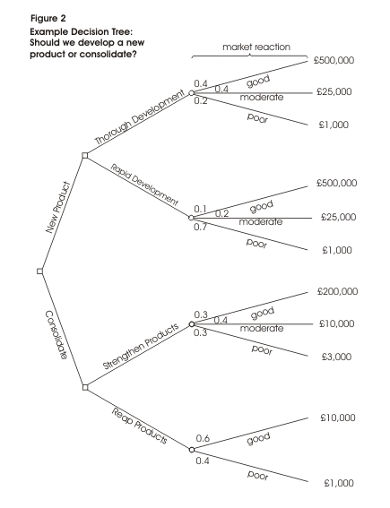

Calculating Tree Values
Once you have worked out the value of the outcomes, and have assessed the probability of the outcomes of uncertainty, it is time to start calculating the values that will help you make your decision.
Start on the right hand side of the decision tree, and work back towards the left. As you complete a set of calculations on a node (decision square or uncertainty circle), all you need to do is to record the result. You can ignore all the calculations that lead to that result from then on.
Calculating the Value of Uncertain Outcome Nodes
Where you are calculating the value of uncertain outcomes (circles on the diagram), do this by multiplying the value of the outcomes by their probability. The total for that node of the tree is the total of these values.
In the example in Figure 2, the value for 'new product, thorough development' is:

0.4 (probability good outcome) x £500,000 (value) = | £200,000
0.4 (probability moderate outcome) x £25,000 (value) = | £10,000
0.2 (probability poor outcome) x £1,000 (value) = | £200
+ | £210,200

Figure 3 shows the calculation of uncertain outcome nodes:

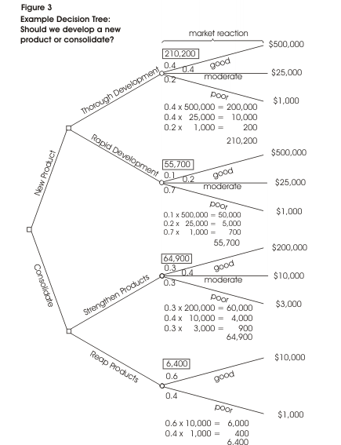
Note that the values calculated for each node are shown in the boxes.
Calculating The Value of Decision Nodes
When you are evaluating a decision node, write down the cost of each option along each decision line. Then subtract the cost from the outcome value that you have already calculated. This will give you a value that represents the benefit of that decision. Note that amounts already spent do not count for this analysis - these are 'sunk costs' and (despite emotional counter-arguments) should not be factored into the decision.
When you have calculated these decision benefits, choose the option that has the largest benefit, and take that as the decision made. This is the value of that decision node.
Figure 4 shows this calculation of decision nodes in our example:
In this example, the benefit we previously calculated for 'new product, thorough development' was £210,000. We estimate the future cost of this approach as £75,000. This gives a net benefit of £135,000.
The net benefit of 'new product, rapid development' was £15,700. On this branch we therefore choose the most valuable option, 'new product, thorough development', and allocate this value to the decision node.
Result:
By applying this technique we can see that the best option is to develop a new product. It is worth much more to us to take our time and get the product right, than to rush the product to market. It is better just to improve our existing products than to botch a new product, even though it costs us less.
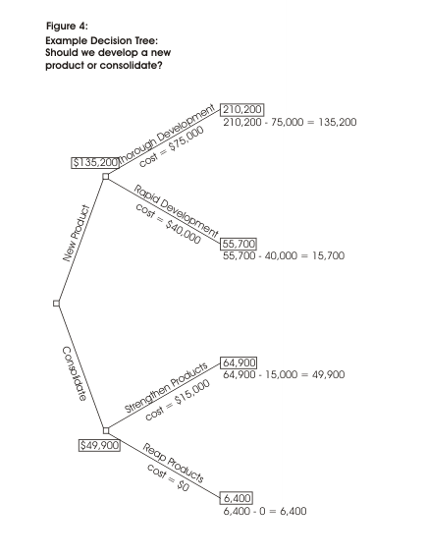
Key points:
Decision trees provide an effective method of Decision Making because they:
- Clearly lay out the problem so that all options can be challenged
- Allow us to analyze fully the possible consequences of a decision
- Provide a framework to quantify the values of outcomes and the probabilities of achieving them
- Help us to make the best decisions on the basis of existing information and best guesses.
As with all Decision Making methods, decision tree analysis should be used in conjunction with common sense - decision trees are just one important part of your Decision Making tool kit.
Many other similar techniques are explained in the book Management Science by Wayne Winston and Christian Albright - this is reviewed at the top of our right hand side bar.

PMI – Weighing the Pros and Cons of a Decision
PMI stands for 'Plus/Minus/Interesting'. It is a valuable improvement to the 'weighing pros and cons' technique used for centuries.
PMI is an important Decision Making tool: the mind tools used so far in this section have focused on selecting a course of action from a range of options. Before you move straight to action on this course of action, it is important to check that it is going to improve the situation (it may actually be best to do nothing!) PMI is a useful tool for doing this.
How to use tool:
To use PMI, download our free worksheet. In the column underneath 'Plus', write down all the positive results of taking the action. Underneath 'Minus' write down all the negative effects. In the 'Interesting' column write down the implications and possible outcomes of taking the action, whether positive, negative, or uncertain.
By this stage it may already be obvious whether or not you should implement the decision. If it is not, consider each of the points you have written down and assign a positive or negative score to it appropriately. The scores you assign may be quite subjective.
Once you have done this, add up the score. A strongly positive score shows that an action should be taken, a strongly negative score that it should be avoided.

Example:
A young professional is deciding where to live. Her question is 'Should she move to the big city?' She draws up the PMI table below:

Plus | Minus | Interesting
More going on (+5) | Have to sell house (-6) | Easier to find new job? (+1)
Easier to see friends (+5) | More pollution (-3) | Meet more people? (+2)
Easier to get places (+3) | Less space (-3) | More difficult to get own work done? (-4)
 | No countryside (-2)
 | More difficult to get to work? (-4)
+13 | -18 | -1

She scores the table as 13 (Plus) - 18 (Minus) - 1 (Interesting) = - 6
For her, the comforts of a settled rural existence outweigh the call of the 'bright lights' - it would be much better for her to live outside the city, but close enough to travel in if necessary.
PMI was codified by Edward de Bono in his book Serious Creativity.
Key points:
PMI is a good way of weighing the pros, cons and implications of a decision. When you have selected a course of action, PMI is a good technique to use to check that it is worth taking.
To use the technique, draw up a table with three columns headed Plus, Minus and Interesting. Within the table write down all the positive points of following the course of action, all the negatives, and all the interesting implications and possible outcomes.
If the decision is still not obvious, you can then score the table to show the importance of individual items. The total score should show whether it is worth implementing the decision.

Force Field Analysis – Understanding the Pressures For and Against Change

Force Field Analysis is a useful technique for looking at all the forces for and against a decision. In effect, it is a specialized method of weighing pros and cons.
By carrying out the analysis you can plan to strengthen the forces supporting a decision, and reduce the impact of opposition to it.
How to Use the Tool:
To carry out a force field analysis, first download our free worksheet and then use it to follow these steps:
- Describe your plan or proposal for change in the middle.
- List all forces for change in one column, and all forces against change in another column.
Assign a score to each force, from 1 (weak) to 5 (strong).
For example, imagine that you are a manager deciding whether to install new manufacturing equipment in your factory. You might draw up a force field analysis like the one in Figure 1:
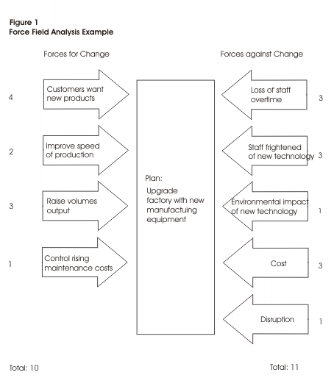
Once you have carried out an analysis, you can decide whether your project is viable. In the example above, you might initially question whether it is worth going ahead with the plan.
Where you have already decided to carry out a project, Force Field Analysis can help you to work out how to improve its probability of success. Here you have two choices:
- To reduce the strength of the forces opposing a project, or
- To increase the forces pushing a project
Often the most elegant solution is the first: just trying to force change through may cause its own problems. People can be uncooperative if change is forced on them.
If you had to implement the project in the example above, the analysis might suggest a number of changes to the initial plan:
- By training staff (increase cost by 1) you could eliminate fear of technology (reduce fear by 2)
- It would be useful to show staff that change is necessary for business survival (new force in favor, +2)
- Staff could be shown that new machines would introduce variety and interest to their jobs (new force, +1)
- You could raise wages to reflect new productivity (cost +1, loss of overtime -2)
- Slightly different machines with filters to eliminate pollution could be installed (environmental impact -1)
These changes would swing the balance from 11:10 (against the plan), to 8:13 (in favor of the plan).
Key points:
Force Field Analysis is a useful technique for looking at all the forces for and against a plan. It helps you to weigh the importance of these factors and decide whether a plan is worth implementing.
Where you have decided to carry out a plan, Force Field Analysis helps you identify changes that you could make to improve it.

Six Thinking Hats – Looking at a Decision From All Points of View
'Six Thinking Hats' is a powerful technique that helps you look at important decisions from a number of different perspectives. It helps you make better decisions by forcing you to move outside your habitual ways of thinking. As such, it helps you understand the full complexity of the decision, and spot issues and opportunities to which you might otherwise be blind.
This tool was created by Edward de Bono in his book '6 Thinking Hats'.
Many successful people think from a very rational, positive viewpoint. This is part of the reason that they are successful. Often, though, they may fail to look at a problem from an emotional, intuitive, creative or negative viewpoint. This can mean that they underestimate resistance to plans, fail to make creative leaps and do not make essential contingency plans.
Similarly, pessimists may be excessively defensive, and more emotional people may fail to look at decisions calmly and rationally.
If you look at a problem with the 'Six Thinking Hats' technique, then you will solve it using all approaches. Your decisions and plans will mix ambition, skill in execution, sensitivity, creativity and good contingency planning.
How to Use the Tool:
You can use the Six Thinking Hats technique in meetings or on your own. In meetings it has the benefit of blocking the confrontations that happen when people with different thinking styles discuss the same problem.
Each 'Thinking Hat' is a different style of thinking. These are explained below:
- White Hat: With this thinking hat you focus on the data available. Look at the information you have, and see what you can learn from it. Look for gaps in your knowledge, and either try to fill them or take account of them. This is where you analyze past trends, and try to extrapolate from historical data.
- Red Hat: 'Wearing' the red hat, you look at problems using intuition, gut reaction, and emotion. Also try to think how other people will react emotionally. Try to understand the responses of people who do not fully know your reasoning.
- Black Hat: Using black hat thinking, look at all the bad points of the decision. Look at it cautiously and defensively. Try to see why it might not work. This is important because it highlights the weak points in a plan. It allows you to eliminate them, alter them, or prepare contingency plans to counter them.
Black Hat thinking helps to make your plans 'tougher' and more resilient. It can also help you to spot fatal flaws and risks before you embark on a course of action. Black Hat thinking is one of the real benefits of this technique, as many successful people get so used to thinking positively that often they cannot see problems in advance. This leaves them under-prepared for difficulties.
- Yellow Hat: The yellow hat helps you to think positively. It is the optimistic viewpoint that helps you to see all the benefits of the decision and the value in it. Yellow Hat thinking helps you to keep going when everything looks gloomy and difficult.
- Green Hat: The Green Hat stands for creativity. This is where you can develop creative solutions to a problem. It is a freewheeling way of thinking, in which there is little criticism of ideas. A whole range of creativity tools can help you here.
- Blue Hat: The Blue Hat stands for process control. This is the hat worn by people chairing meetings. When running into difficulties because ideas are running dry, they may direct activity into Green Hat thinking. When contingency plans are needed, they will ask for Black Hat thinking, etc.
A variant of this technique is to look at problems from the point of view of different professionals (e.g. doctors, architects, sales directors, etc.) or different customers.
Example:
The directors of a property company are looking at whether they should construct a new office building. The economy is doing well, and the amount of vacant office space is reducing sharply. As part of their decision they decide to use the 6 Thinking Hats technique during a planning meeting.
Looking at the problem with the White Hat, they analyze the data they have. They examine the trend in vacant office space, which shows a sharp reduction. They anticipate that by the time the office block would be completed, that there will be a severe shortage of office space. Current government projections show steady economic growth for at least the construction period.
With Red Hat thinking, some of the directors think the proposed building looks quite ugly. While it would be highly cost-effective, they worry that people would not like to work in it.
When they think with the Black Hat, they worry that government projections may be wrong. The economy may be about to enter a 'cyclical downturn', in which case the office building may be empty for a long time.
If the building is not attractive, then companies will choose to work in another better-looking building at the same rent.
With the Yellow Hat, however, if the economy holds up and their projections are correct, the company stands to make a great deal of money.
If they are lucky, maybe they could sell the building before the next downturn, or rent to tenants on long-term leases that will last through any recession.
With Green Hat thinking they consider whether they should change the design to make the building more pleasant. Perhaps they could build prestige offices that people would want to rent in any economic climate. Alternatively, maybe they should invest the money in the short term to buy up property at a low cost when a recession comes.
The Blue Hat has been used by the meeting's Chair to move between the different thinking styles. He or she may have needed to keep other members of the team from switching styles, or from criticizing other peoples' points.

Key points:
Six Thinking Hats is a good technique for looking at the effects of a decision from a number of different points of view.
It allows necessary emotion and skepticism to be brought into what would otherwise be purely rational decisions. It opens up the opportunity for creativity within Decision Making. The technique also helps, for example, persistently pessimistic people to be positive and creative.
Plans developed using the '6 Thinking Hats' technique will be sounder and more resilient than would otherwise be the case. It may also help you to avoid public relations mistakes, and spot good reasons not to follow a course of action before you have committed to it.

Cost/Benefit Analysis – Evaluating Quantitatively Whether to Follow a Course of Action
You may have been intensely creative in generating solutions to a problem, and rigorous in your selection of the best one available. However, this solution may still not be worth implementing, as you may invest a lot of time and money in solving a problem that is not worthy of this effort.
Cost Benefit Analysis or CBA is a relatively simple and widely used technique for deciding whether to make a change. As its name suggests, you simply add up the value of the benefits of a course of action, and subtract the costs associated with it.
Costs are either one-off, or may be ongoing. Benefits are most often received over time. We build this effect of time into our analysis by calculating a payback period. This is the time it takes for the benefits of a change to repay its costs. Many companies look for payback over a specified period of time e.g. three years.
How to use tool:
In its simple form, cost-benefit analysis is carried out using only financial costs and financial benefits. For example, a simple cost benefit ration for a road scheme would measure the cost of building the road, and subtract this from the economic benefit of improving transport links. It would not measure either the cost of environmental damage or the benefit of quicker and easier travel to work.
A more sophisticated approach to building a cost benefit models is to try to put a financial value on intangible costs and benefits. This can be highly subjective - is, for example, a historic water meadow worth $25,000, or is it worth $500,000 because if its environmental importance? What is the value of stress-free travel to work in the morning?
These are all questions that people have to answer, and answers that people have to defend.
The version of the cost benefit approach we explain here is necessarily simple. Where large sums of money are involved (for example, in financial market transactions), project evaluation can become an extremely complex and sophisticated art.
Example:
A sales director is deciding whether to implement a new computer-based contact management and sales processing system. His department has only a few computers, and his salespeople are not computer literate. He is aware that computerized sales forces are able to contact more customers and give a higher quality of reliability and service to those customers. They are more able to meet commitments, and can work more efficiently with fulfillment and delivery staff.
His financial cost/benefit analysis is shown below:
Costs:
New computer equipment:
- 10 network-ready PCs with supporting software @ $1,225 each
- 1 server @ $1,750
- 3 printers @ $600 each
- Cabling & Installation @ $2300
- Sales Support Software @ $7500
Training costs:
- Computer introduction - 8 people @ $ 200 each
- Keyboard skills - 8 people @ $ 200 each
Sales Support System - 12 people @ $350 each
Other costs:
- Lost time: 40 man days @ $ 100 / day
- Lost sales through disruption: estimate: $10,000
- Lost sales through inefficiency during first months: estimate: $10,000
Total cost: $55,800
Benefits:
- Tripling of mail shot capacity: estimate: $20,000 / year
- Ability to sustain telesales campaigns: estimate: $10,000 / year
- Improved efficiency and reliability of follow-up: estimate: $25,000 / year
- Improved customer service and retention: estimate: $15,000 / year
- Improved accuracy of customer information: estimate: $5,000 / year
- More ability to manage sales effort: $15,000 / year
Total Benefit: $90,000/year
Payback time: $55,800 / $90,000 = 0.62 of a year = approx. 8 months
Tip:
The payback time is often known as the break even point. Sometimes this is more important than the overall benefit a project can deliver, for example because the organization has had to borrow to fund a new piece of machinery. The break even point can be found graphically by plotting costs and income on a graph of output quantity against $. Break even occurs at the point the two lines cross.

Inevitably the estimates of the benefit given by the new system are quite subjective. Despite this, the Sales Director is very likely to introduce it, given the short payback time.
Key points:
Cost/Benefit Analysis is a powerful, widely used and relatively easy tool for deciding whether to make a change.
To use the tool, firstly work out how much the change will cost to make. Then calculate the benefit you will from it.
Where costs or benefits are paid or received over time, work out the time it will take for the benefits to repay the costs.
Cost/Benefit Analysis can be carried out using only financial costs and financial benefits. You may, however, decide to include intangible items within the analysis. As you must estimate a value for these, this inevitably brings an element of subjectivity into the process.
*Larger projects are evaluated using formal finance/capital budgeting, which takes into account many of the complexities involved with financial Decision Making. This is a complex area and is beyond the scope of this site, however books on capital budgeting are shown on the side bar

Exercise:
Using Decision Trees in Everyday Life
Think about the decisions you make each semester before registering for your college subjects. Your subject selections are no doubt driven to a large extent by the requirements of your curriculum. Your selection of specific subjects are probably influenced by such factors as the instructor, the time of day, conflicts with other classes, and conflicts with work schedules. Your decision process probably has some sequential elements to it: for example, “if I schedule this class at this time, then these classes cannot be scheduled because…” Develop a tree diagram to illustrate the sequential decision aspects of the class scheduling process that you went trough this semester.

